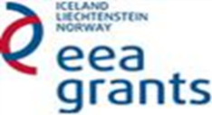
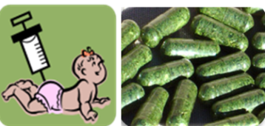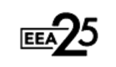

EEA Norway-Romania SmartVac project
Kick-off meeting

Venue: NIBIO Ås, meeting room H8 (Høgskoleveien 8, 1431 Ås)
October 28, 2019
Chair: Jihong Liu Clarke
Group photo before meeting begins
10:00 -10:10 Welcome and short introduction of NIBIO- Arne Hermansen Director of Biotechnology and Plant Health Division, NIBIO
10:10-10:20 Welcome all consortium partners – Jihong Liu Clarke, Research Professor and Coordinator for China Relations, NIBIO
10:20-10:40 EEA Financial Mechanism –Cristina Mihai, Senior adviser,
Research Council of Norway
10:40-11:10 Brief introduction of the Institute of Biochemistry of the Romanian
Academy and EEA SmartVac project- Norica Nichita, Professor, Institute of
Biochemistry
11:10-11:30 Algae transformation and molecular farming at Max Planck Inst-
Ralph Bock, Professor and Director, Max Planck Institute of Molecular Plant Physiology
11:30-12:30 Short presentations by NIBIO and Romanian partners (10 min each)
- Novel HBV antigens, design production and characterization - Olivia Dobrica, Researcher, Institute of Biochemistry
- Glycosylation of plant-derived recombinant proteins- using N.benthamiana made cellobiohydrolase TrCel7A as a show study - Andre Eerde, Researcher, NIBIO
- Novel HCV antigens, design, production and characterization - Costin-Ioan Popescu, Researcher, Institute of Biochemistry
- Microalgae research at NIBIO – Kari Skjånes, Researcher, NIBIO
12:30-13:30 Lunch
13:30-16:30 SmartVac project plan and discussion (According to each WP)
16:30-17:00 Wrap up the meeting – Norica, Jihong, Ralph and Hanne/Kari
17:00-20:00 Dinner at Vitenparken Ås
October 29, 2019
10:00-14:00 Visit of the NIBIO’s Green House
October 30, 2019
10:00-16:00 Meeting with NIBIO’s project coordinator, Professor Jihong Liu Clarke.
Focused discussion on current project activities and future collaborations.

