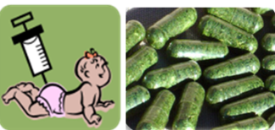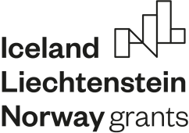

EEA Norway-Romania SmartVac project meeting

Time: October 24-26/2022

Tuesday October 25th, Institute of Biochemistry
10-10:30 Meeting with Dr. Stefana Petrescu, Director of the IBRA: guest introduction, the contribution of the EEA Norway/Romania projects towards increasing institutional capacity-building and collaboration.
10:30- 13:00 Norwegian Master Student project discussion and activity planning
13:00-14:00 Light Lunch
14:00- 14:30 Seminar Professors Jihong Liu-Clarke (NIBIO)
“Urban farming for plant-made oral vaccines- beyond the EEA SmartVac and EU-China H2020 flagship SiEuGreen projects”.
14:30-15:30 Dr. Norica Nichita (IBRA), update on the progress of the SmartVac project
18:00- Dinner

Wednesday October 25th
10:00-13:00 Visit at the “Cantacuzino” Medico-Military Institute for Research and
Development (P2), TBC
14:00- Lunch
15:00-18:00 Sightseeing, informal discussion between partner team members
18:00- Dinner

Thursday October 26th
8:00 Professor Jihong Liu-Clarke’s departure to Otopeni Airport

