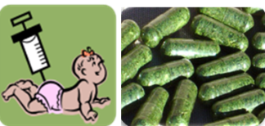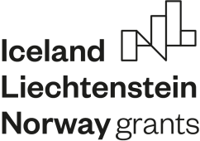

EEA Norway-Romania SmartVac project
IIIrd annual meeting

Time: June 10-13/2022

Thursday June 9th, arrival of guests
19:00- Welcome Dinner

Friday June 10th, Institute of Biochemistry
10-10:30 Dr. Stefana Petrescu, Director of the IB: guest introduction, welcome address.
10:30- 14:00 Dr. Norica Nichita (IB): presentation of the institute departments, facilities, collaboration opportunities
14:00-14:30 Light Lunch
14:30- 16:00 Dr. Norica Nichita (IB), Professors Jihong Liu-Clarke (NIBIO) and Ralph Bock (NIBIO/MPI-MP): discussion on funding opportunities beyond the SmartVac project, EU funding, Horizon Europe calls, European Innovation Council calls, “Hop on” facility (Horizon Europe). Online participation by ZOOM, for project members who are not physically present.
18:00- Dinner

Saturday June 11th, travel to Sinaia
18:00- Dinner

Sunday June 12th Conference Hall “Foisorul cu Flori” Hotel, Sinaia
10:00-12:00 Dr. Popescu Costin-Ioan (IB), Dr. Crina Stavaru (CI): Increasing dissemination and public communication of the SmartVac project results.
12:00-13:30 Dr. Norica Nichita (IB): Project management, data publication, revision of currently-submitted manuscripts and preparation of novel submissions.
13.30-14.30 Lunch
14:30- Informal discussion between partner team members
18:00- Dinner

Monday June 13th , Conference Hall “Foisorul cu Flori” Hotel, Sinaia; Online participation by ZOOM, for project members who are not physically present.
9.30-10:30 Dr. Norica Nichita (IB): Generation and characterization of novel HBV vaccine candidates (Data from WP1, WP4, WP5, WP6)
10:30-11:30 Dr. Costin Ioan Popescu (IB): Generation and characterization of novel HCV antigens (Data from WP1, WP4, WP5, WP6)
11:30-12:30 Discussion on project progress on design and production of HBV/HCV antigens; potential delays, backup plans.
12:30-13:30 Lunch
13:30-14:30 Dr. Andre van Eeerde (NIBIO): Updates on HBV/HCV antigens expression in N. benthamiana and L. sativa (Data from WP2).
14:30-15:00 Discussion on WP2, future activities
15:00-15:15 Coffee break
15:15-16:15 Alexander Hammel (MPI-MP), Updates on HBV/HCV protein expression in microalgae (Data from WP3).
16:15-16:45 Discussion on WP3, future activities
16:45-17:45 Dr. Crina Stavaru (INCDMM Cantacuzino), Evaluation of the immunogenicity of HBV and HCV vaccine candidates expressed in plants and algae (Data from WP5).
17:45-18:15 Discussion on WP5, future activities
18:15-19:00 Roundtable conclusions and closing remarks
19:00- Dinner

Tuesday June 14th
9:00 Departure to Bucharest, via Otopeni Airport

