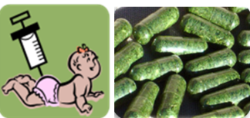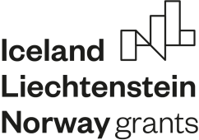

EEA Norway-Romania SmartVac project
Ist annual meeting

Time: August 20-21, 2020, Videoconference

Thursday, August 20th
Chair: Dr. Norica Nichita
14:00-14:10 Opening address
14:10-15:15 WP1: Design and cloning novel (“smart”) HBV/HCV antigens with improved immunogenic properties.
14:10-14:30 Dr. Olivia Dobrica (IBRA), Updates on HBV cloning and screening (A1.1, A1.2)
14:30-15:00 Dr. Ionut Popescu (IBRA), Updates on HCV cloning and screening (A 1.3-1.7)
15:00-15:15 Discussions on WP1, future planning
15:15-16:15 WP2: Production of the designed HBV and HCV vaccine antigens in N. benthamiana and lettuce plants using plant transient expression system
15:15-16:00 Andre van Eeerde, Updates on viral antigens expression in N. benthamiana and L. sativa (A.2.1-2.4).
16:00-16:15 Discussions on WP2, future planning
16:15-17:15 WP3: Production of the designed HBV and HCV vaccine antigens in microalgae
16:15-16:30 Ralph Bock (MPI-MP), Updates on optimization of microalgal transformation/expression protocols (A3.1)
16:30-17:00 Alexander Hammel (MPI-MP), Updates on viral protein expression in microalgae (A3.2)
17:00-17:15 Discussions on WP3, future planning

Friday, August 21st
Chair: Dr. Jihong Liu-Clarke
10:00- 11:00 WP4: Characterization of HBV/HCV antigens produced in alternative expression systems (mammalian cells, plants, algae)
10:00-10:20 Dr. Olivia Dobrica (IBRA), Updates on molecular and functional characterization of HBV antigens produced so far (A 4.1, 4.2)
10:20-10:40 Lia-Maria Cucos (IBRA), Updates on molecular and functional characterization of HCV antigens produced so far (A 4.3, 4.4).
10:40-11:00 Discussions on WP4, future planning
11:00-12:15 WP5: Comparative evaluation of the immunogenic properties of HBV/HCV antigens produced in alternative expression systems
11:00-11:15 Ana-Maria Pantazica (IBRA), Updates on purification of HBV antigens (A 5.1)
11:15-11.30 Lia-Maria Cucos (IBRA), Updates on purification of HCV antigens (A 5.2)
11:30-12:00 Crina Stavaru/ Catalin Tucureanu, INCDMM Cantacuzino , Updates on “in vitro” evaluation of the immunogenicity of HBV and HCV vaccine candidates and adjuvants. (A 5.3)
12:00-12:15 Discussions on WP5, future planning
12:15-12:30 WP7: Project management, capacity building and results dissemination
12:15-12:30 Drs. Norica Nichita & Jihong Liu-Clarke, Updates on management activities, discussions (A 7.1-7.6).
12:30-13:00 Roundtable conclusions and closing remarks

